Task1
Retrieve information (author, title, and price) about books whose price is less than or equal to the average price of books in the warehouse. Display the information sorted in descending order by price. Calculate the average as the mean book price.

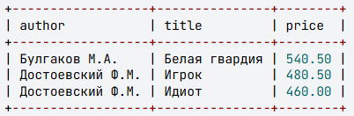

Task2
Retrieve information (author, title, and price) for books where their price exceeds the minimum book price in the warehouse by no more than 150 rubles. Sort the results in ascending order by price.
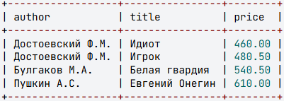

Task3
Retrieve information (author, title, and quantity) for books where the number of copies in the book table is not duplicated.
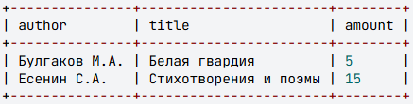
Explanation of the task
In the book table, the amount column stores the number of copies of each book:
According to this table:
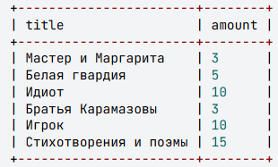
- The number of copies for "Master and Margarita" and "The Brothers Karamazov" is the same (3). Since the number 3 appears twice in the table, books with this quantity do not meet the condition.
- The number of copies for "The Idiot" and "The Gambler" is also the same (10), so they also do not meet the condition.
- The number of copies for "The White Guard" is 5, and there are no other books with the same quantity in the table. Therefore, this book meets the condition (as the quantity 5 is not duplicated in the table).
- The number of copies for "Poems and Poetry" is 15, and there are no other books with the same quantity in the table. Thus, this book also meets the condition.
Therefore, it is necessary to output the rows from the table where the values in the amount column are unique (not repeated).
Prompt
In the subquery, select those values from the amount column for which the count, calculated using the COUNT() function, equals 1.

Task 4
Retrieve information about books (author, title, price) where the price is less than the largest value among the minimum prices calculated for each author.
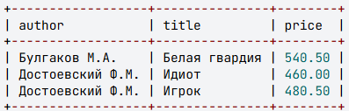

Task5
Calculate how many copies of each book need to be ordered from suppliers so that the stock quantity of each book becomes equal to the maximum quantity of any single book currently in stock. Display the book title, its author, the current stock quantity, and the number of copies to be ordered. Name the last column 'Order'. Exclude books that do not need to be ordered from the result.
